Click “Create New Virtual Machine”.

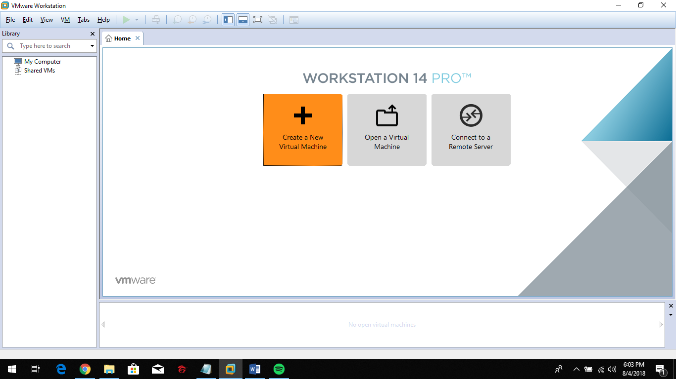

Choose “Typical (recommended)”. Click next to proceed.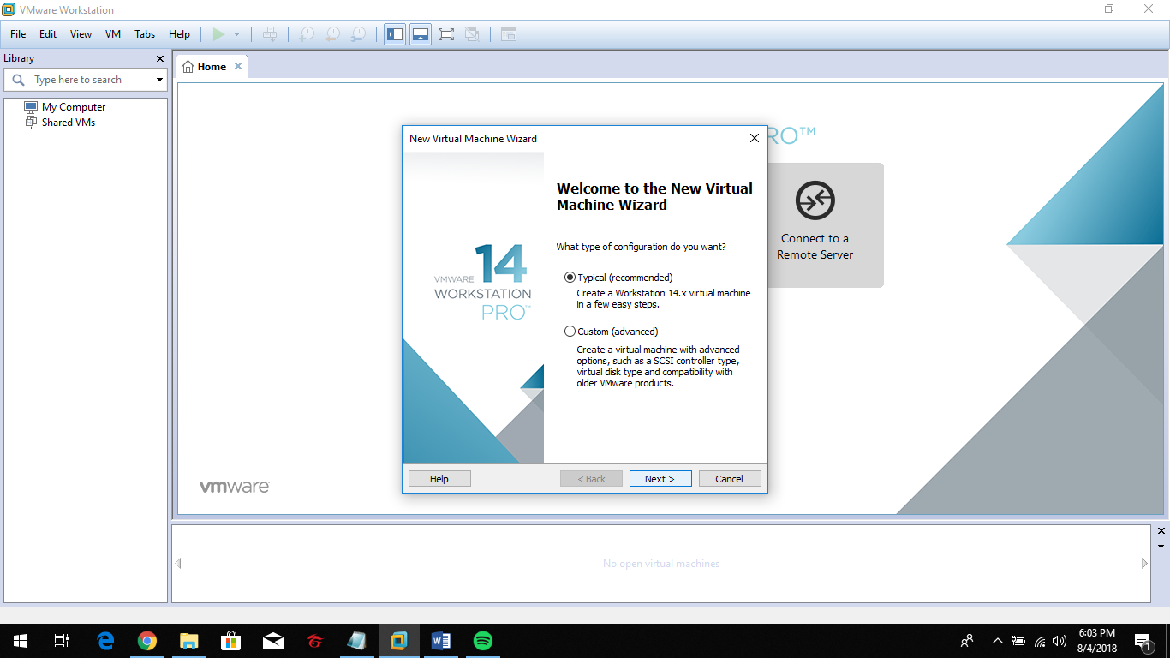

Choose “I will install the operating system later”. Click next to proceed.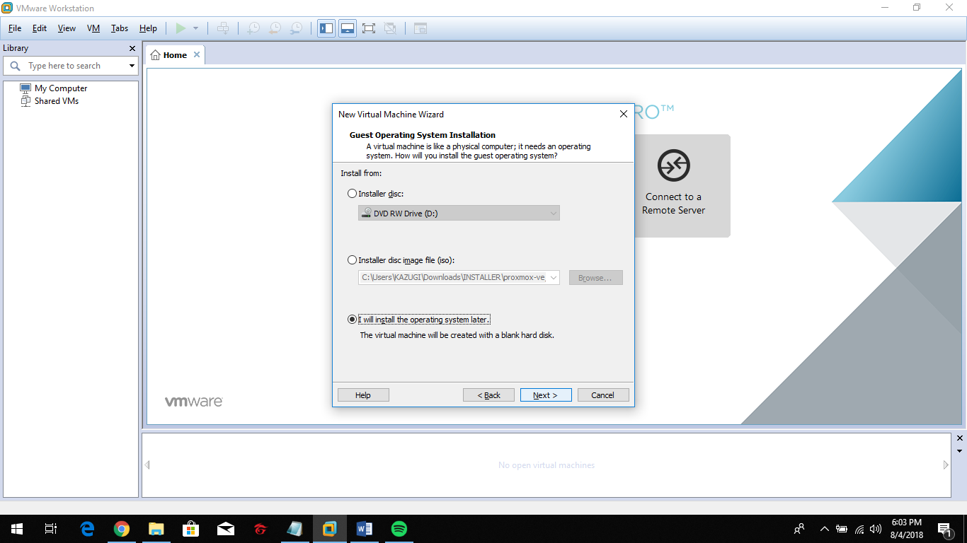

Choose “Linux” as Guest operating System and select the version. Click next to proceed.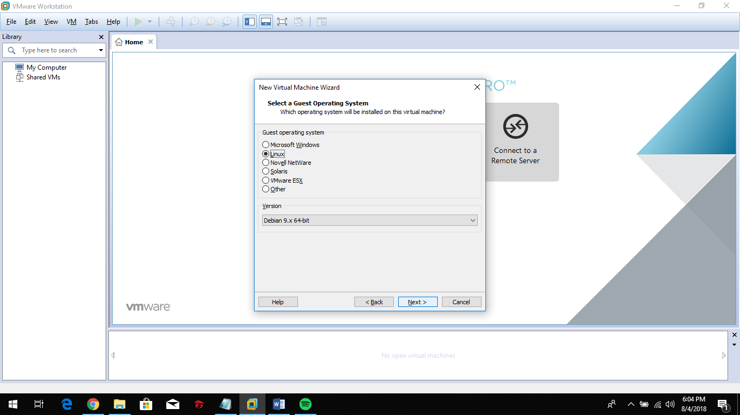

Create virtual machine name and browse the location to be set. Click next to proceed.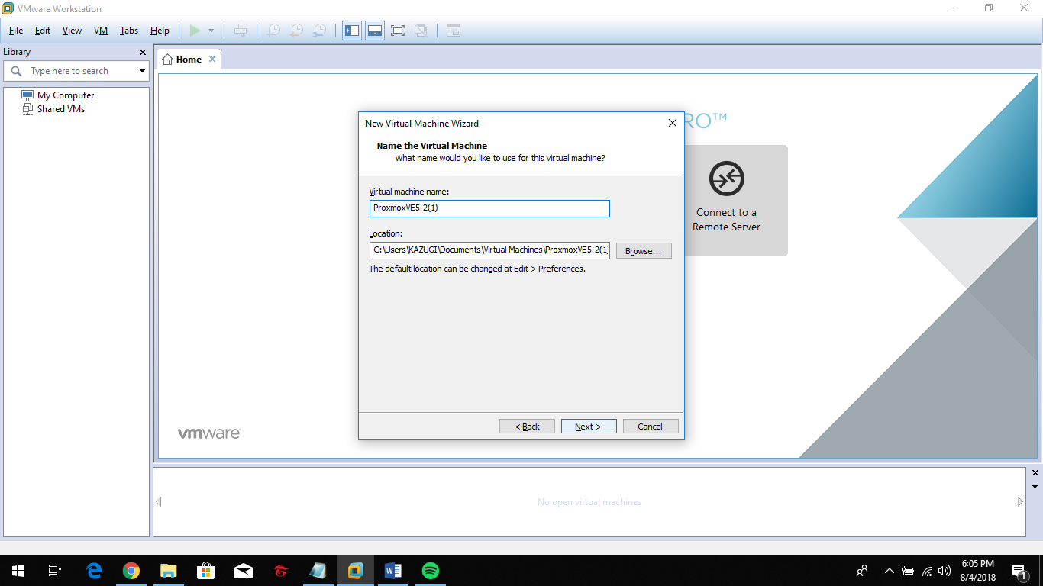

Set the disk size and click “Store virtual disk as single file”. Click next to proceed.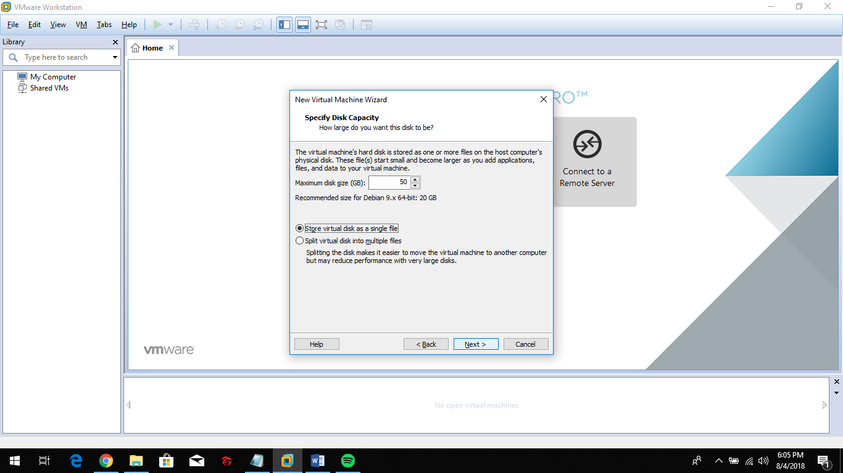

Click “Customize Hardware”.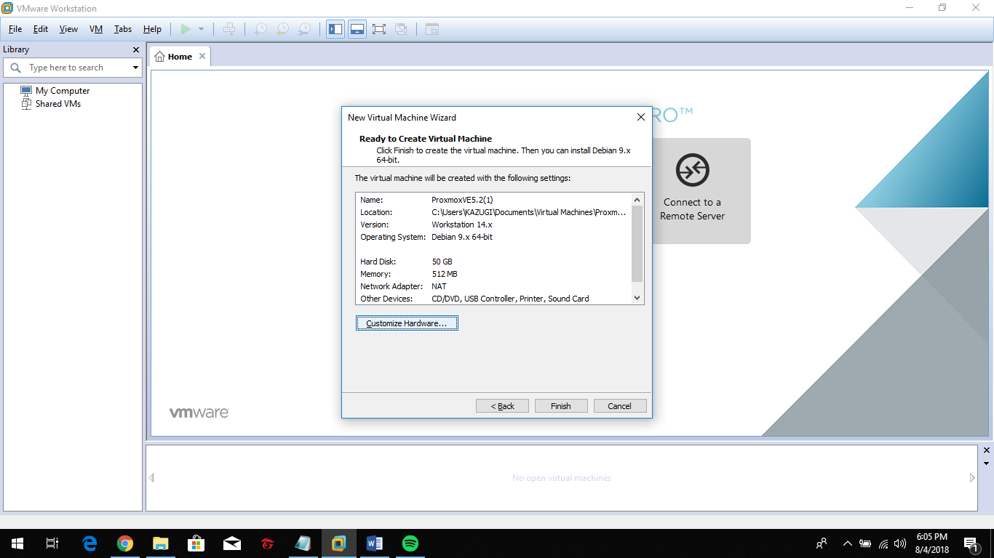

Click “Memory” to set the size of Memory for the virtual machine.

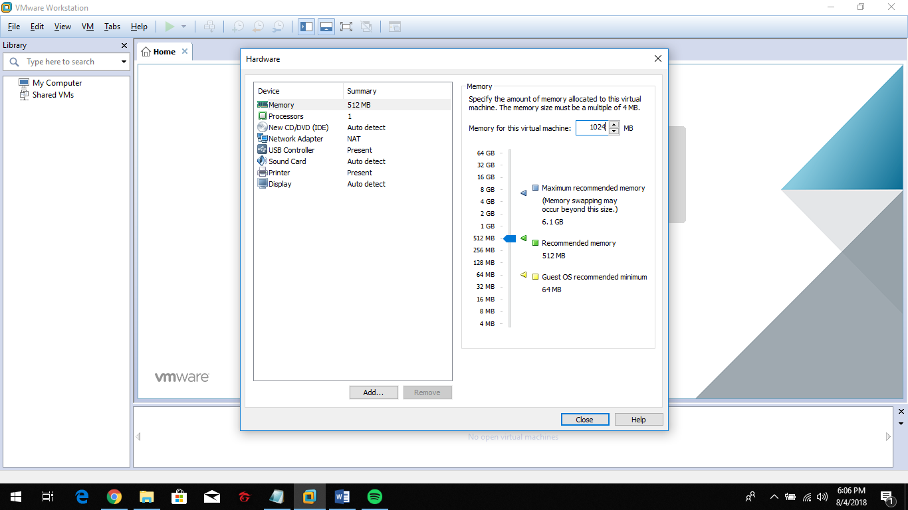

Click “Processor” to select the “Number of processors”, “Number of cores per processor”, and “Virtualize Intel VT-x/EPT or AMD-V/RVI” for “Virtualization Engine”.

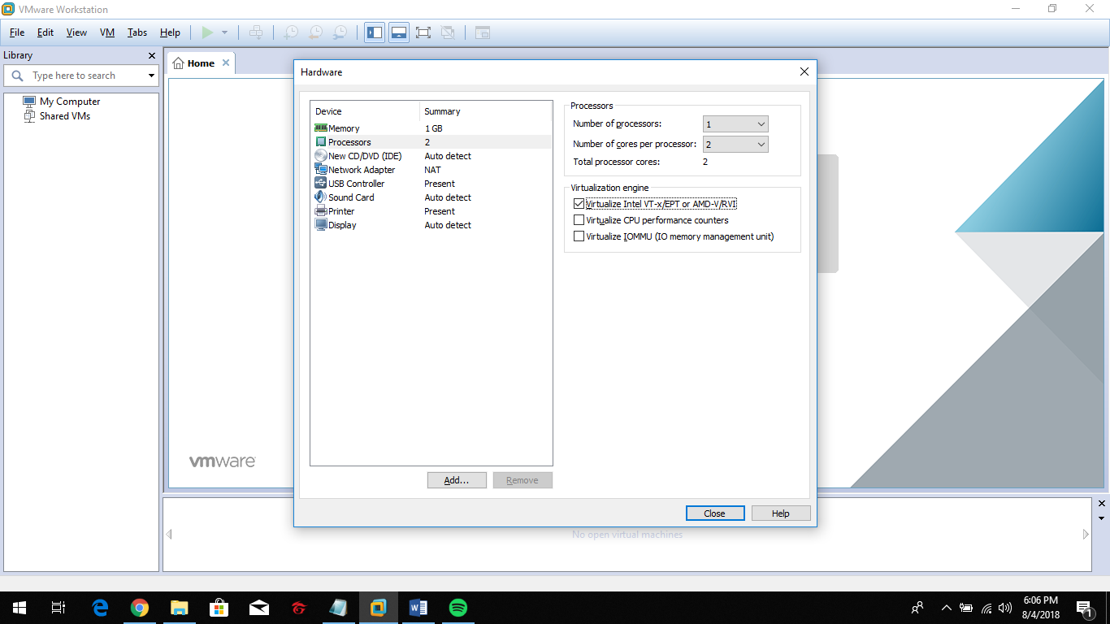

Click “New CD/DVD (IDE)” to choose “use ISO image file” for “Connection”.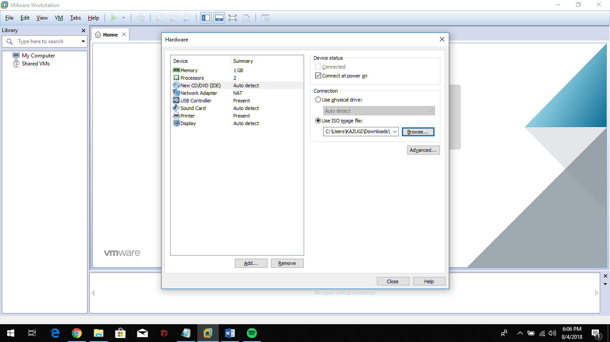

Click “Network Adapter” to select the “Network connection”.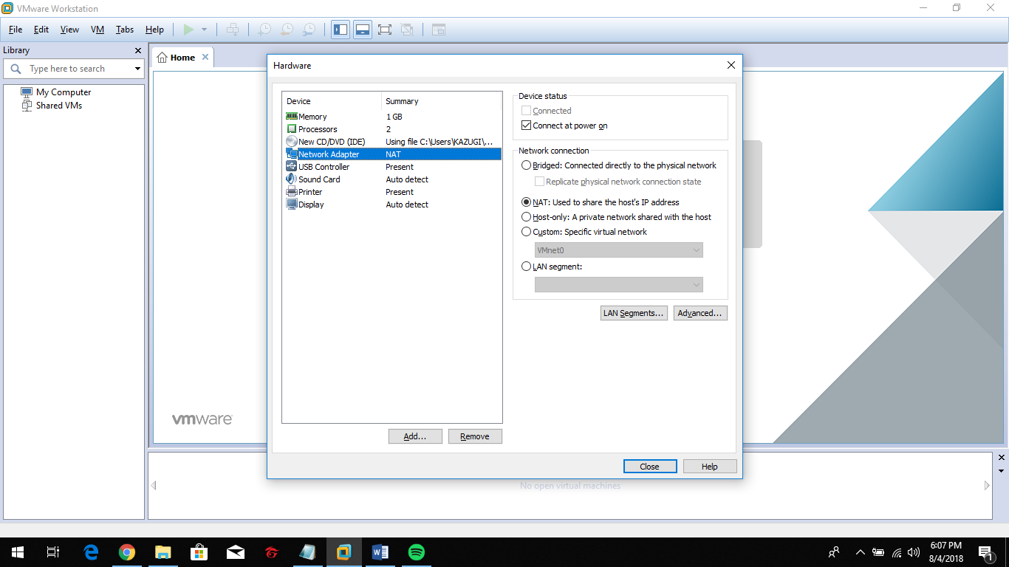

Click “Finish” to successfully create a new virtual machine.